
INDIVIDUAL ASSIGNMENT
Module
Module Code

Name:
FERDINAND TASLIM
TP072735

Intake Code : APD3F2511CS(DA)
Module code : CT110-3-3-BSMA
Module title : Behavioural Science and Marketing Analytics
Lecturer name : Dr. Nohman Khan
Hand out date : Week 4
Submission date : Week 12
Tutorial No. : 11
Word Count : 3145

Table of Contents
Table of Contents 2
I. Introduction & Background: Nintendo 3
II. Emerging Technology: AI, AR, and Computer Vision in Gaming 4
2.1 Overview 4
2.2 Nintendo's Application of Emerging Technologies 5
2.2.1 Hardware and Upscaling (AI) 5
2.2.2 Spatial Interaction (AR and Computer Vision) 6
2.2.3 Ecosystem and Personalization 7
III. Importance of Protecting Intellectual Property 8
3.1 Strategic Value of IP 8
3.2 Patent Protection 8
3.3 Data Governance and Copyright 8
IV. Financial Options Available to Nintendo 10
4.1 Internal Research and Development 10
4.2 Strategic Partnerships, Acquisitions, and Venture Capital 10
4.3 Government Grants and Public Funding 11
References 12

I. Introduction & Background: Nintendo

Nintendo was founded in 1889 in Kyoto, Japan initially as a producer of hanafuda playing cards. During the late 1970s, Nintendo transitioned into an electronic entertainment company which gain global recognition with the release of the home video game console, the Nintendo Entertainment System (NES). Today, Nintendo is an industry leader in the gaming industry with markets operating across North America, Europe, and Asia. As a long-standing industry leader, it has a proven track record of creating highly popular characters and franchises (Liao, 2024), including Super Mario, The Legend of Zelda, Metroid, and Splatoon.
Figure 1. Nintendo's company logo
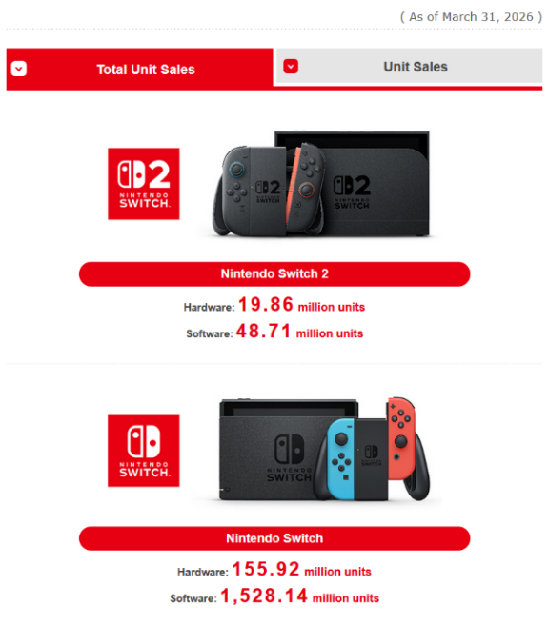
As of early 2026, the Nintendo Switch family has sold over 150 million units worldwide, making it ranked among the best-selling consoles in history. Unlike its competitors Sony and Microsoft, Nintendo tries to avoid raw hardware races. Instead, it prioritizes accessibility, gameplay innovation, and family-friendly entertainment, a philosophy famously termed "Lateral Thinking with Withered Technology" by designer Gunpei Yokoi (Mandel & Ju, 2024). Following the 2025 launch of the Nintendo Switch 2, Nintendo continues to expand its digital ecosystem by integrating Emerging Technologies, specifically Artificial Intelligence (AI), Augmented Reality (AR), and Computer Vision into its hardware and software systems.
Figure 2. Total unit sales of Nintendo Switch and Nintendo Switch 2
By controlling hardware design, software development, online services, and digital distribution within a single ecosystem, Nintendo can seamlessly embed these technologies throughout the user experience. Rather than chasing expensive hardware specifications, Nintendo utilizes AI, AR, and computer vision strategically to optimize performance, enhance gameplay quality, and lower production barriers while maintaining affordable, energy-efficient consumer hardware.

II. Emerging Technology: AI, AR, and Computer Vision in Gaming

Overview
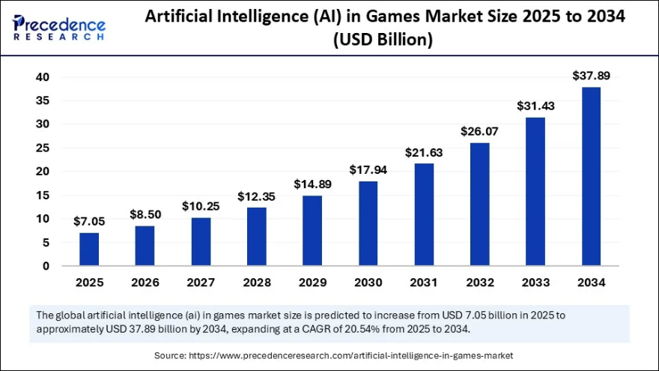
The modern gaming landscape is evolving by the implementation of AI, AR, and computer vision. AI in gaming utilizes machine learning, neural networks, and generative models to improve development workflows and player experiences. While traditional gaming AI focuses on rigid, scripted rules, modern machine learning adapts gameplay dynamically by analyzing player behavior in real time (Roohi et al., 2018). On the other hand, AR and computer vision brings physical spaces to life by introducing virtual 3D models, animations, and sound effects, creating a seamless, simultaneous interaction between the real world and digital overlays (Zuo et al., 2022).
According to industry data, the global AI and immersive gaming market was valued at approximately USD 7 billion in 2025 and is projected to reach USD 26 billion by 2032 (Precedence Research, 2025), highlighting its accelerating commercial importance.
Figure 3. Projected market size for AI in Games (Precedence Research, 2025)
Even though the industry is evolving rapidly, Nintendo maintains a cautious, highly selective approach toward generative AI. According to Shintaro Furukawa (Nintendo’s company president), video games and AI have always evolved together. However, while generative AI opens up new possibilities, it also brings up tricky copyright issues. He made it clear that while Nintendo is open to using new tech, the company will rely on its decades of expertise to create unique experiences that artificial intelligence simply can't copy (Nintendo, 2024).

Nintendo's Application of Emerging Technologies
Nintendo treats these emerging tools as enhancements to human imagination rather than replacements. During the development of The Legend of Zelda: Tears of the Kingdom, engineers utilized automated machine learning tools and physics-based optimization systems to manage complex environmental interactions and large-scale asset streaming. However, core creative elements like puzzle mechanics and level progression remained strictly hand-designed.

Hardware and Upscaling (AI)
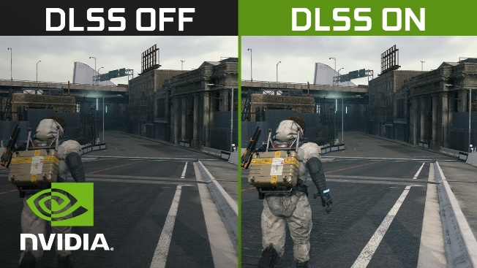
A primary hardware application of AI is featured within the Nintendo Switch 2 architecture. Released in June 2025, the system abandons traditional brute-force rendering in favor of a custom NVIDIA processor that is equipped with an Ampere-based GPU containing 1,536 CUDA cores and dedicated Tensor cores. By using NVIDIA’s AI-powered DLSS, the console leverages machine learning to deliver smoother visuals, realistic lighting, and faster processing speeds (Gargiulo et al., 2025).
Figure 4. DLSS Upscaling feature to increase resolution without wasting more power
DLSS functions by rendering complex game scenes internally at lower resolutions (such as 720p or 1080p) to conserve battery life, manage thermal thresholds, and minimize physical component wear during portable play. The on-chip AI Tensor cores then execute trained neural network algorithms in real time to intelligently predict and reconstruct missing pixels, upscaling the image to a high resolution 4K output at 60 frames per second when connected to an external display via the hardware dock (Anda, 2025).
Beyond resolution enhancement, the console utilizes its hardware-accelerated RT Cores to execute real-time ray tracing and complex ray reconstruction. This system simulates the physical behavior of light, which map highly accurate reflections, refractive surfaces, and ambient shadows natively on a mobile chipset to make the games look more realistic and up to date.
Concurrently, the Nintendo European Research & Development (NERD) division focuses on proprietary machine learning frameworks designed to execute deep-learning anti-aliasing (DLAA) (Whitehead, 2021). By balancing rendering tasks between specialized AI silicon and traditional hardware, Nintendo achieves high-tier graphical performance on an incredibly conservative power envelope.

Spatial Interaction (AR and Computer Vision)
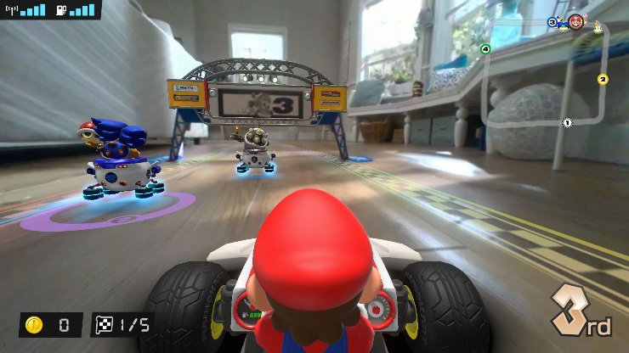
Simultaneously, Nintendo has established a unique footprint in AR and computer vision, prioritizing shared physical play over isolating Virtual Reality (VR) headsets, which has failed them before. This approach is anchored by physical-digital hybrids like Mario Kart Live: Home Circuit. This system uses a physical RC car with a built-in camera to stream real-world surroundings, while digitally adding virtual hazards and rivals. This allows players to design their own courses and race through them as fictional mascots (Kerdvibulvech, 2022).
Figure 5. Mario Kart Live: Home Circuit brings the classic franchise to the real world with AR
The software utilizes sophisticated computer vision algorithms to run real-time simultaneous localization and mapping (SLAM). By scanning the physical architecture of the floor, detecting human-placed spatial gates, and tracking high-contrast visual markers, the software builds a geometric layout of the user’s home. Once mapped, the game put digital items, physical obstacles, and virtual enemies over the real-world footage, turning a living room into an interactive racetrack.
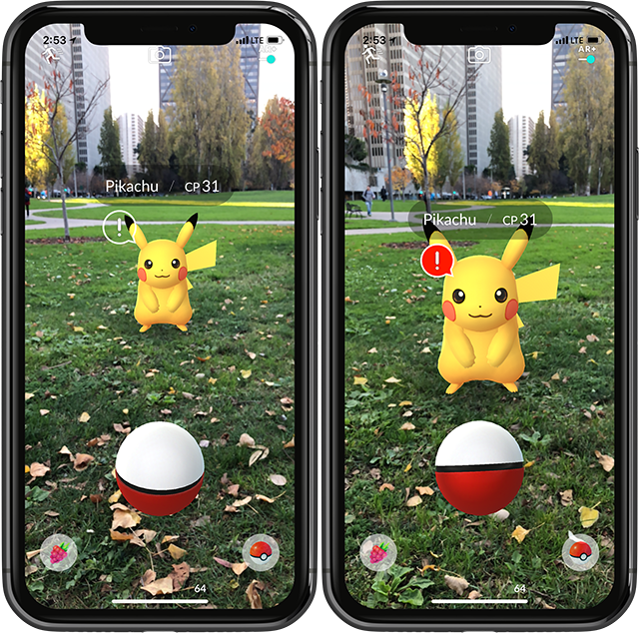
This philosophy has been further advanced by Nintendo's venture in Location-based augmented reality games (LBGs), which overlay digital components onto physical environments, creating gameplay experiences that blend real-world surroundings with virtual spaces (Laato et al., 2022). In location-based AR titles like Pokemon GO (co-developed with Niantic), Nintendo integrates geospatial positioning data with real-time semantic segmentation. This computer vision technique classifies camera feed frames to distinguish between distinct real-world surfaces, ensuring that pokemons recognize and physically anchor themselves to grass, concrete, or water.
Figure 6. Pokemon GO, a mobile game utilizing AR

Ecosystem and Personalization
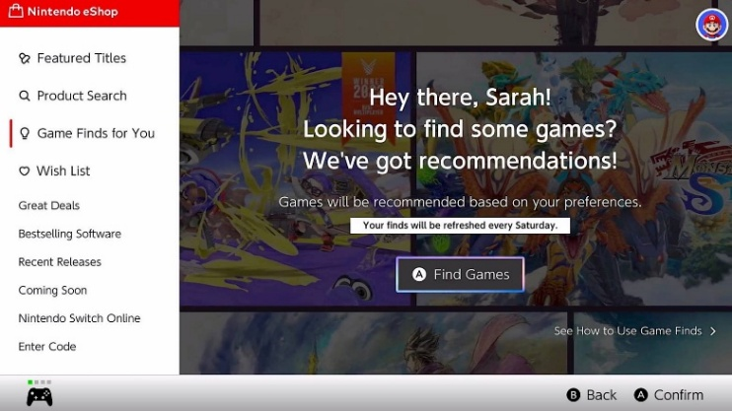
Within its digital ecosystem, Nintendo deploys machine learning algorithms on the Nintendo eShop to personalize game recommendations based on browsing history and play patterns. Additionally, patents filed by Nintendo reveal ongoing development in AI-driven adaptive difficulty systems. These systems track biometric and telemetry data from player inputs to dynamically tune game physics and enemy behavior. This intersection of computer vision, AR tracking, and adaptive machine learning ensures that Nintendo's gaming experiences remain highly accessible, regardless of a player's physical environment or skill level.
Figure 7. AI-based recommendation in Nintendo eShop

III. Importance of Protecting Intellectual Property

Strategic Value of IP
Intellectual property (IP) is Nintendo’s core commercial asset. In the context of ETs, these systems generate immense value through proprietary upscaling algorithms, custom physical spatial markers, trained neural network weights, and behavioral datasets. Each asset requires stringent protection through patents, trade secrets, and copyrights to prevent competitors from cloning Nintendo’s unique hardware-software interactions (WIPO, 2023).
If a competitor were to freely copy Nintendo’s computer vision tracking or adaptive difficulty algorithms, the distinctiveness of its ecosystem would be severely diluted. Because open-source machine learning and AR libraries are widely accessible, a company's proprietary implementation and data curation serve as its primary competitive differentiators.

Patent Protection and Trade Secrets
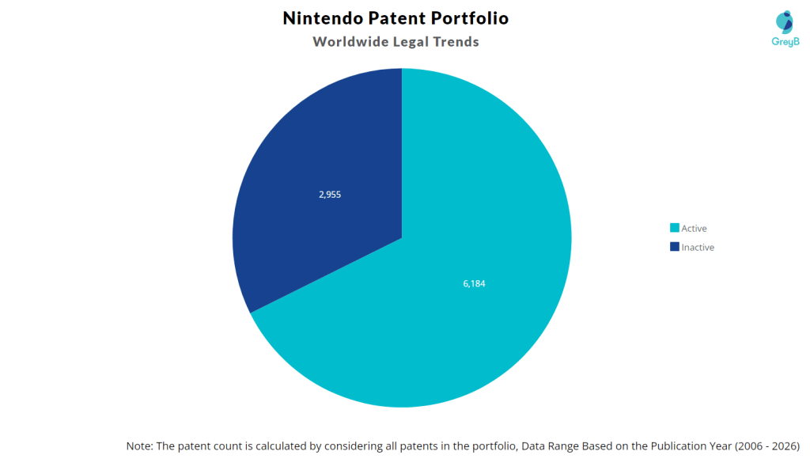
Figure 8. Number of Patents owned by Nintendo (Insights by Grey, 2026)
Patents provide the legal framework necessary to protect Nintendo’s hardware inventions and software mechanisms. The company aggressively secures patents for its physical-digital hybrids amounting to a total of 6184 active patents, spanning early motion-control mechanics to modern machine learning applications and camera-based spatial tracking tools.
However, not all ET assets are suited for patent disclosure; many are more effectively guarded as trade secrets. These include proprietary behavioral training datasets, refined neural network weights, internal automated QA testing procedures, and specialized camera calibration code for AR hardware. Unlike patents, trade secrets offer indefinite protection, provided strict confidentiality is maintained. Nintendo compiles massive repositories of telemetry data from millions of active global users to train its engines, enforcing robust cybersecurity architectures and comprehensive non-disclosure agreements (NDAs) to shield these assets.

Data Governance and Copyright
Nintendo must balance data utilization with international privacy mandates, including Japan’s Act on the Protection of Personal Information (APPI) and the European Union’s General Data Protection Regulation (GDPR). Maintaining compliant data governance ensures Nintendo protects its critical training data while preserving consumer trust.
Furthermore, copyright law protects Nintendo’s creative expressions, such as source code, character designs, environmental art, and musical scores. These copyrighted works are vital inputs when training proprietary machine learning models or generating AR assets. To mitigate legal ambiguity regarding purely AI-generated outputs, Nintendo maintains strict internal governance ensuring that any software utilizing machine learning or AR mapping involves substantial human creative intervention.

IV. Financial Options Available to Nintendo
Figure 9. Nintendo's 2026 balance sheet (Nintendo, 2026)

Internal Research and Development
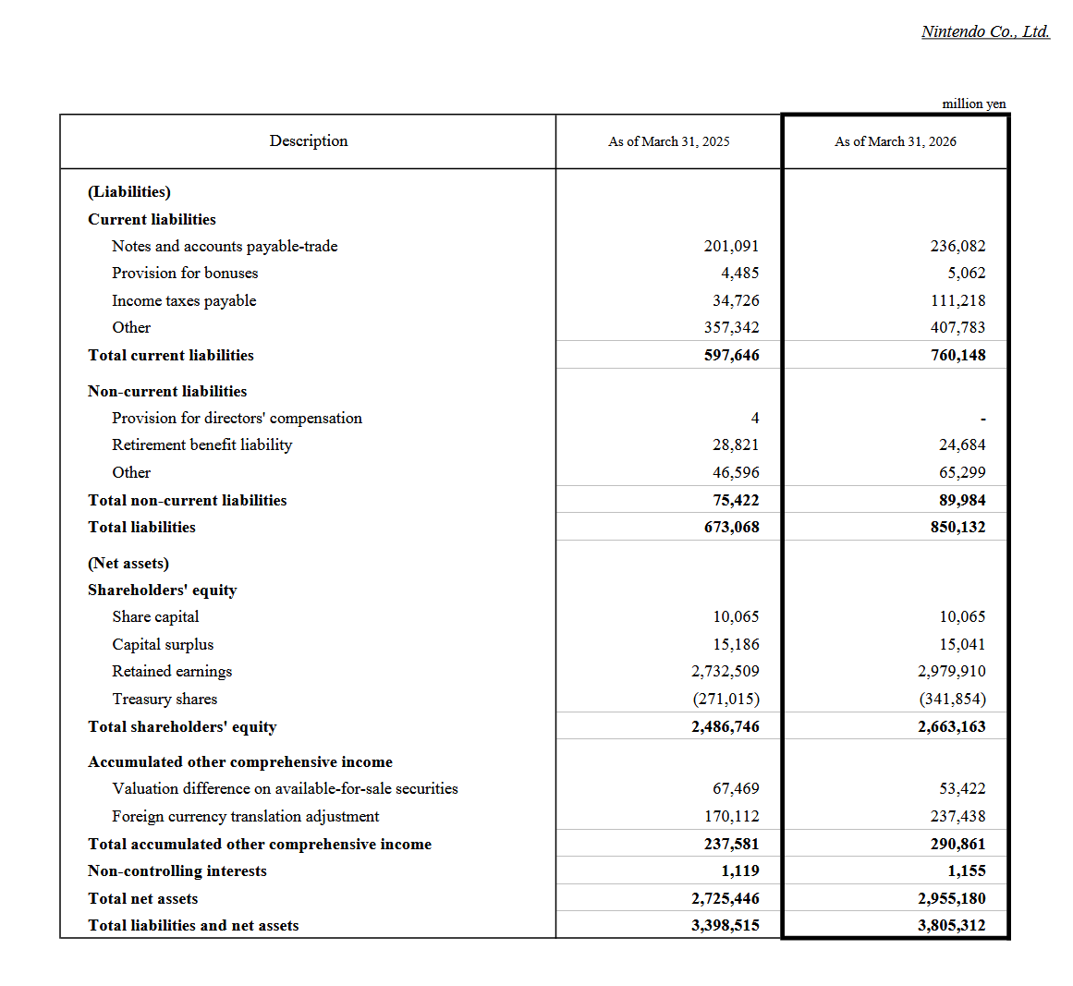
Nintendo primarily funds its emerging technology research through internal cash reserves and retained earnings. Rather than relying on external debt, the company maintains a highly liquid financial strategy, as evidenced by its 1.316 trillion Japanese Yen in cash and cash equivalents reported at the close of the fiscal year ending March 31, 2026. Furthermore, the company’s total assets grew to 3.805 trillion Yen, backed by an accumulation of 2.979 trillion Yen in retained earnings.
This immense internal liquidity provides Nintendo with the self-sustaining capital necessary to bankroll continuous technology research without surrendering equity. Capital is directed into highly specialized avenues—such as mobile computer vision, spatial mapping, and low-power AI upscaling—allowing Nintendo to achieve high consumer impact and hardware efficiency while maintaining an exceptionally high capital adequacy ratio.

Strategic Partnerships, Acquisitions, and Venture Capital
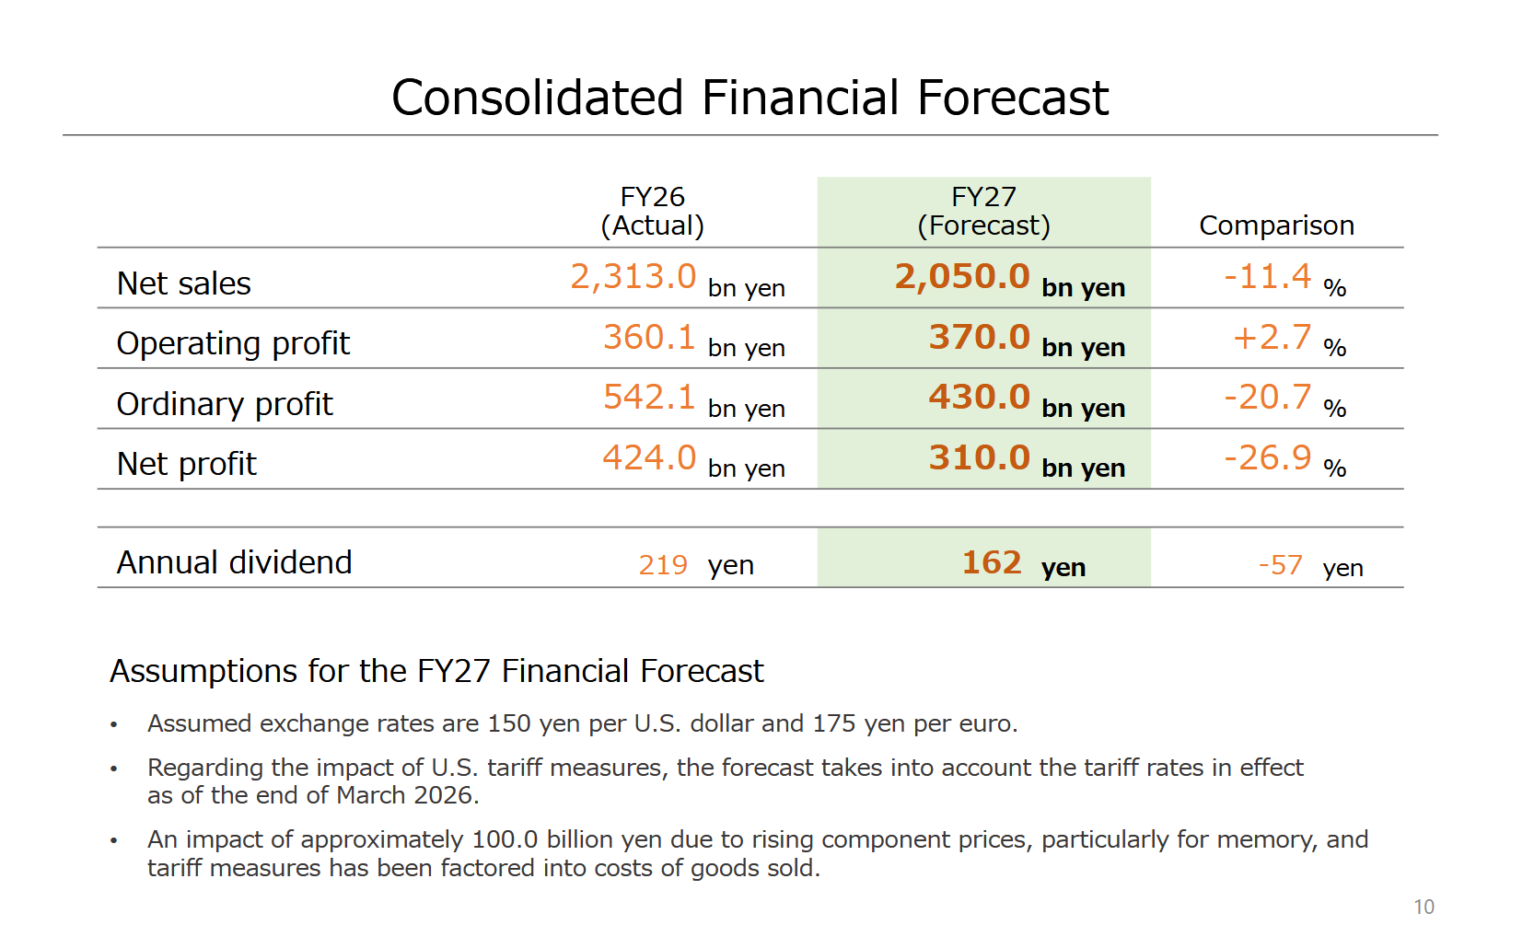
Figure 10. Nintendo's 2026 consolidated financial forecast (Nintendo, 2026)
To complement its focused internal R&D, Nintendo strategically deploys targeted partnerships and acquisitions to secure technical talent and mitigate upfront financial risk. The commercial validity of this approach was highlighted by the June 2025 global launch of the Nintendo Switch 2 hardware, which propelled annual consolidated net sales to 2.313 trillion Japanese Yen for the fiscal year ended March 31, 2026.
Integrating NVIDIA’s DLSS into this architecture stands as a prime example of a strategic alliance. By collaborating with an established hardware leader, Nintendo gains access to cutting-edge AI upscaling models while avoiding the multi-billion dollar costs associated with independent silicon research.
Furthermore, Nintendo can leverage its strong financial positioning—bolstered by an operating profit of 360.1 billion Yen and an ordinary profit of 542.1 billion Yen—to pursue boutique acquisitions or Corporate Venture Capital (CVC). Beyond its primary cash holdings, the company maintains a robust multi-tiered investment buffer, holding 425.0 billion Yen in short-term liquid securities alongside 420.8 billion Yen in long-term investment securities as of March 31, 2026. Deploying this capital into specialized tech startups allows Nintendo to secure a first-look advantage on emerging tools.

Government Grants and Public Funding
Public financing and state-sponsored initiatives provide a valuable, non-dilutive mechanism to subsidize Nintendo's long-term technology research. Under Japan’s national AI and digital transformation strategies, bodies such as the Ministry of Economy, Trade and Industry (METI) offer substantial grants to enterprises researching advanced technologies in tandem with academic institutions.
Nintendo stands as an ideal candidate for state-level backing due to its massive role in bolstering Japan’s domestic economy and projecting global cultural soft power. Major franchises like Pokémon serve as vital cultural exports, driving international merchandise sales, media consumption, and tourism. The global popularity of Nintendo’s intellectual property helps strengthen Japan’s soft power and international entertainment industry. As a result, the Japanese government views public support for Nintendo's core research as a direct investment in maintaining the nation's technological and cultural competitiveness in the global entertainment sector.

References
Liao, K. (2024, July). Nintendo strategy analysis report. In 2024 9th International Conference on Social Sciences and Economic Development (ICSSED 2024) (pp. 771-777). Atlantis Press.
Mandel, I., & Ju, W. (2024, July). Designing with What Remains. In Proceedings of the 2024 ACM Designing Interactive Systems Conference (pp. 3002-3015).
Roohi, S., Takatalo, J., Guckelsberger, C., & Hämäläinen, P. (2018, April). Review of intrinsic motivation in simulation-based game testing. In Proceedings of the 2018 chi conference on human factors in computing systems (pp. 1-13).
Zuo, T., Jiang, J., Spek, E. V. D., Birk, M., & Hu, J. (2022). Situating learning in AR fantasy, design considerations for AR game-based learning for children. Electronics, 11(15), 2331.
Precedence Research. (2025). Artificial Intelligence in Games Market Size to Hit USD 37.89 Billion by 2034. Precedenceresearch.com; Precedence Research. https://www.precedenceresearch.com/artificial-intelligence-in-games-market
Nintendo Co., Ltd. (2024). The 84th Annual General Meeting of Shareholders Q&A Summary (English Translation of Japanese Original). https://www.nintendo.co.jp/ir/pdf/2024/qa2406e.pdf
Gargiulo¹, A., Leone¹, D., & Ferretti¹, M. (2025, November). New Frontiers for Value Co-Creation in the Entertainment Industry. In XXII SIM Conference 2025 (p. 718).
Anda, M. (2025, April 3). Nintendo Switch 2 Leveled Up With NVIDIA AI-Powered DLSS and 4K Gaming. NVIDIA Blog. https://blogs.nvidia.com/blog/nintendo-switch-2-leveled-up-with-nvidia-ai-powered-dlss-and-4k-gaming/
Whitehead, T. (2021, October). Patent Reveals Nintendo Is Working On Upscaling Technology. Nintendo Life. https://www.nintendolife.com/news/2021/10/patent_reveals_nintendo_is_working_on_upscaling_technology
Kerdvibulvech, C. (2022). Geo‐Based Mixed Reality Gaming Market Analysis. Human Behavior and Emerging Technologies, 2022(1), 1139475.
Laato, S., Fernández Galeote, D., Altarriba Bertran, F., & Hamari, J. (2022, April). Balancing the augmented experience: design tensions in the location-based game Pikmin Bloom. In CHI Conference on Human Factors in Computing Systems Extended Abstracts (pp. 1-7).
Insights by Grey. (2026). Nintendo Patents - Key Insights and Stats. (2024, September 10). Insights;Gate. https://insights.greyb.com/nintendo-patents/
Nintendo Co., Ltd. (2026). Consolidated financial highlights. https://www.nintendo.co.jp/ir/pdf/2026/260508e.pdf
Nintendo Co., Ltd. (2026). Financial Results Explanatory Material Fiscal Year Ended March 2026. https://www.nintendo.co.jp/ir/pdf/2026/260508_4e.pdf

